Tenda MW5s-Network delay is high. What should I do？

User Scenario One:
Other people are downloading network resources (files/videos). Network delay is high when I am playing online games.
User Scenario Two:
Other people are watching video, Network delay is high when I am playing online games.

Solutions:

You can turn on QoS function to ensure smooth gaming and web browsing.

Step 1: Open APP, tap “Settings” > “QoS”.

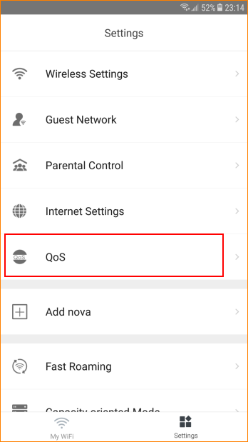

Step 2: Please enter reasonable download speed and upload speed. Then tap “Save”.

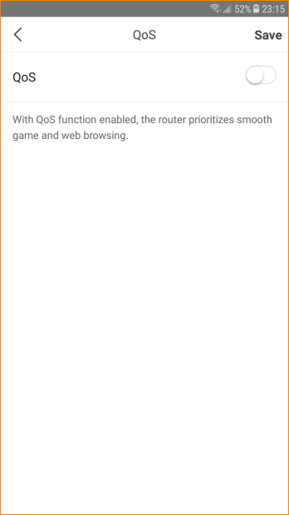

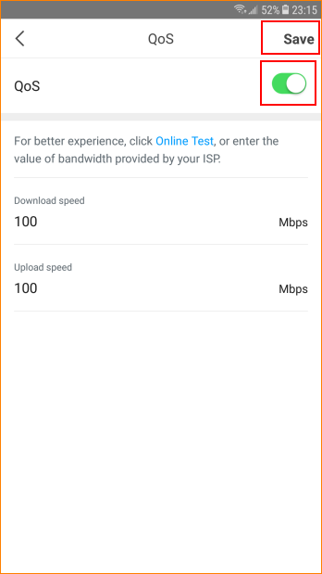

Note: If you do not know your bandwidth, please ask ISP for help. Or you can tap “Online Test” to test your speed.

